Demo Module 8: The Silverlight Application Wrapper Web Part

**Demo Overview**: The first part of the document explains the step to take to have Silverlight up and running on your machine and in SharePoint.

The second part of the document explains how to install and use the Silverlight Application Wrapper Web Part. A Silverlight application can be hosted in a SharePoint web part by means of a **Silverlight <object>** tag.

# Part 1: Install Silverlight and Configure SharePoint

1. Download the **Silverlight 3 runtime**: <http://silverlight.net/GetStarted/>
2. Install the Silverlight runtime.
3. If you want to develop your own Silverlight applications with Visual Studio 2008, you have to download and install the **Silverlight Tools for Visual Studio 2008 SP1**: <http://silverlight.net/GetStarted/>. It will also install the **Silverlight 3 SDK**.
4. Configure the Silverlight **MIME type**:
   1. Open **IIS Manager** and select the SharePoint web application.
   2. Double-click the MIME Types icon

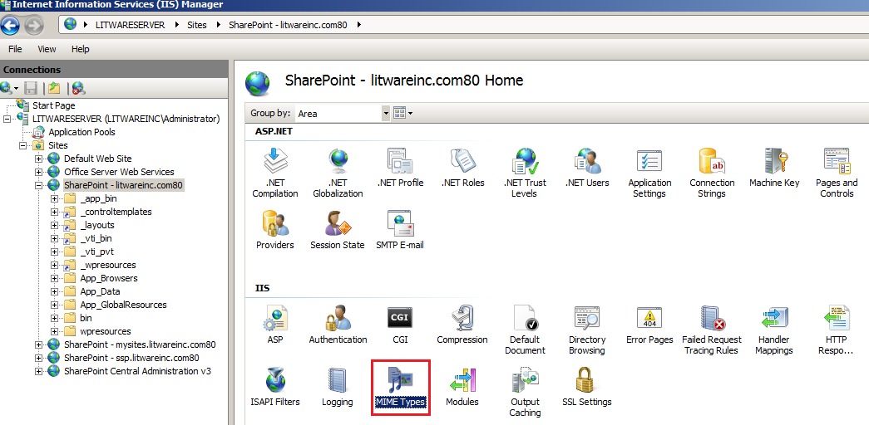

* 1. Check if there is already the **.xap** extionsion in the list (with Windows Server 2008 it is possible it is). If not, select the Add.. link in the Actions pane (at the righ) and fill out the following:
     1. Extension: .xap
     2. MIME type: application/x-silverlight

1. Configure the **web.config** of your SharePoint application. The easiest way is to use Visual Studio 2008 (if you haven’t already done that for adding AJAX support):
   1. Open **Visual Studio 2008** and create a new **ASP.NET 2.0 Web Site.**

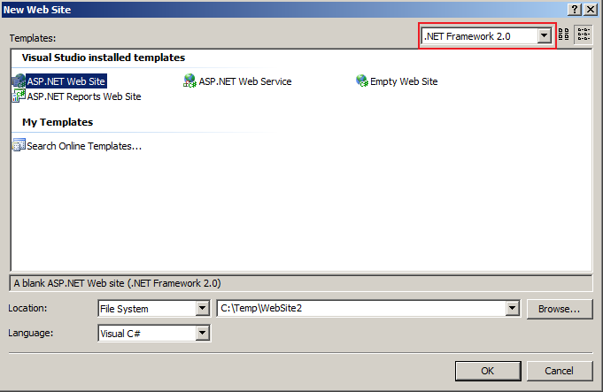

* 1. Navigate to the C**:\inetpub\wwwroot\wss\VirtualDirectories\litwareinc.com80** directory of your SharePoint web application.
  2. Make a backup copy of the **web.config**.
  3. Open the **web.config** of your SharePoint web application.
  4. Copy the content of this web.config into the **web.config** of the newly created web site.
  5. Right-click the web site project in **Solution Explorer** and choose **Property Pages**.
  6. Choose the **Build** option.
  7. In **Target Framework** section, choose **.NET Framework 3.5**.
  8. Click the **OK** button. This will upgrade your **web.config** for use with the .NET Framework 3.5.

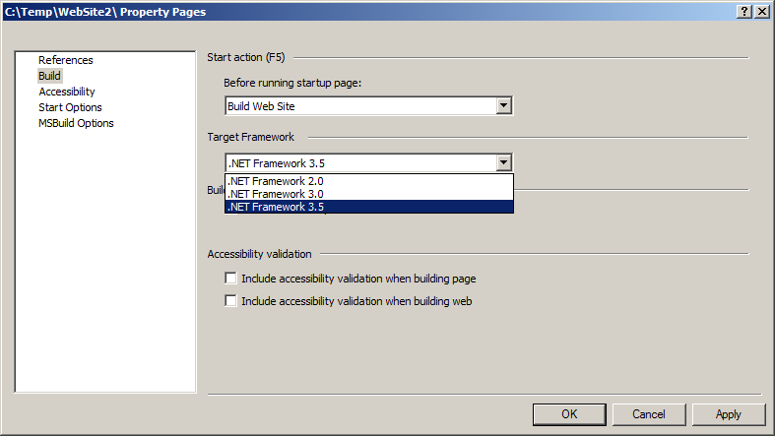

* 1. You can see this upgrade by inspecting the section group **system.web.extensions** right under the SharePoint section group.
  2. Inspect also the node for the **HttpHandlers** in system.web node.
  3. Copy paste the content of the upgraded web.config into the web.config of your SharePoint web application.

1. Save your changes. Now your web.config is ready for integrating AJAX and Silverlight in SharePoint.

# Part 2: Create the lists and document libraries

1. The Silverlight wrapper solution package also contains a Silverlight application **SilverlightCalculator.xap**. It is not of important use in SharePoint but it shows how you can host a Silverlight application within a SharePoint web part. This Silverlight application will be uploaded into a document library. So create a document library with the name **XAPS** in [**http://litwareinc.com**](http://litwareinc.com).
2. The second Silverlight application demonstrates Silverlight data binding in SharePoint. Therefore you will have to install two extra lists:
   1. Upload the **Books.stp** list template which will install a template for a Picture Library with book thumbnails.
   2. Upload the **Favorite Books.stp** list template which will install a list template for information about favorite SharePoint books.
   3. Create a list based on the **Books Picture Library** template and give it the name **Books**.
   4. Create a list based on the **Favorite Books** template and give it the name **Favorite Books**.

# Part 3: Show the code of the Silverlight Wrapper Web Part

1. Open the project **Silverlight Wrapper WebPart** in **Visual Studio 2008**.
2. Open the **SilverlightWrapper.cs** file.
3. Show the custom properties that will be added to the **Silverlight** category:
   1. the **Width** property: you need to specify a width in pixels, otherwise you will not see your Silverlight application.
   2. the **Height** property: you need to specify a height in pixels, otherwise you will not see your Silverlight application.
   3. the **Source** property: will contain the URL to the Silverlight application.
   4. The **InitParams** property: if the Silverlight application needs some initial parameters to be passed in, they can be specified in this property.
4. Show the **OnPrerender** method: it loads the **Silverlight.js** that comes with the Silverlight 3 SDK. In this demo it is deployed to the **_layouts\Silvelright 3 Core** folder, together with the feature. But if you count on using Silverlight extensively within SharePoint, you can better create a separate feature that deploys the **Silverlight.js** file as a **ControlTemplate** so that it loads with the **AdditionalPageHead** delegate control.
5. Show the **Render** method where the Silverlight **<object>** is rendered. Notice properties like:
   1. Width
   2. Height
   3. Source
   4. InitParams
   5. MinimumVersion

# Part 4: Install the solution package

1. Open **Windows Explorer** and navigate to the location of the demo. Run the **DeploySolutionPackage.cmd** which is located in the **Package** sub directory and which will:
   1. create a solution package
   2. add the solution to the solution store and
   3. deploy the solution.
2. Open **Internet Explorer** and browse to [**http://litwareinc.com**](http://litwareinc.com).
3. Go to **Site Settings** and choose **Site Collection Features**.
4. Activate the **Silverlight Wrapper** feature.

# Part 5: Test the web part

1. The Silverlight wrapper solution package also contains two Silverlight applications:
   1. The **SilverlightCalculator.xap** which will be uploaded in the **XAPS** document library. This is a simple Silverlight application with no interaction with SharePoint.
   2. The **SL.XAML.BookViewer.xap** which will be installed in the **Favorite Books** sub folder of the **LAYOUTS** folder. This Silverlight application demonstrates the following aspects:
      1. use of the **initParams** parameter,
      2. communication with SharePoint using the **HttpWebRequest** object to call the SharePoint web services,
      3. data binding
2. Create a web part page.
3. Edit the page and add the **Silverlight Application Wrapper** Web Part (from the **Silverlight Web Parts** group) to the page.
4. Modify the web part and expand the **Bindings** category.
5. Set the Source property to **/XAPS/SilverlightCalculator.xap**.
6. Click the **Apply** button and then the **OK** button.
7. The Silverlight calculator should appear.

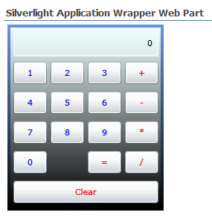

# Part 6: The data binding application

1. Important parts in the Silverlight application code:
   1. The initial parameters in the **App.xaml.cs** file.
   2. **HttpWebRequest** in **Page.xaml.cs** file.
2. Return to the web part page and edit the page again.
3. Add another **Silverlight Application Wrapper** web part to the page.
4. This time set
   1. the **Source** property to **/_LAYOUTS/Favorite Books/SL.XAML.BookViewer.xap**
   2. the **InitParams** property to **siteurl=http://litwareinc.com,listname=Favorite Books** (should be a comma delimited string)
5. Click the Apply button and then the OK button. The web part should appear:

